UNIVERCITY ADMISSION PREDICTION SYSTEM

**Introduction**:

The objective is to explore what kind of data is provided, determine the most important factors that contribute to a student's chance of admission, and select the most accurate model to predict the probability of admission.

**Data Description**

The dataset contains information about a student's:

* GRE Score
* TOEFL Score
* University Ratings
* Statement of Purpose Score
* Letter of Recommendation Score
* CGPA
* Whether the Student Has Done Any Research
* Chance of Admission (What We're Trying to Predict)

**Implementation of project:**

**1. Importing following libraries**: First step of the project is importing following libraries

import numpy as np

import pandas as pd

*#import os*

from matplotlib import pyplot as plt

from sklearn import preprocessing

from sklearn.preprocessing import StandardScaler

from sklearn.model_selection import train_test_split

from sklearn.linear_model import LinearRegression

from sklearn.tree import DecisionTreeRegressor

from sklearn.ensemble import RandomForestRegressor

import seaborn as sns

**2. Data Pre-processing:** Next we have to prepare our data for building our model, for that we do data pre-processing on our dataset. Next, let's import our dataset. From our dataset it looks like we have no missing values.

**3. Preparing Data for Machine Learning**: Now that we understand our dataset, it's time to implement machine learning methods to predict future applicant's chances of admission. First we have to prepare our data, by splitting it into training and testing data. We'll also scale our data, from 0 to 1, to receive more accurate predictions. We have split our data as 80% for training and 20% for testing.

**4. Machine Learning**: Now we'll implement machine learning algorithms to predict the chance of admission. We'll use multiple techniques and eventually select the method with the best score. The methods used will be:

1. Linear Regression
2. Decision Trees
3. Random Forests

From executing above algorithms, it is observed that linear regression gives 82.12% accuracy, decision tree gives 65.04% accuracy and random forest gives 82.64% accuracy. Since random forest algorithm gives better accuracy we are using random forest algorithm for building the model.

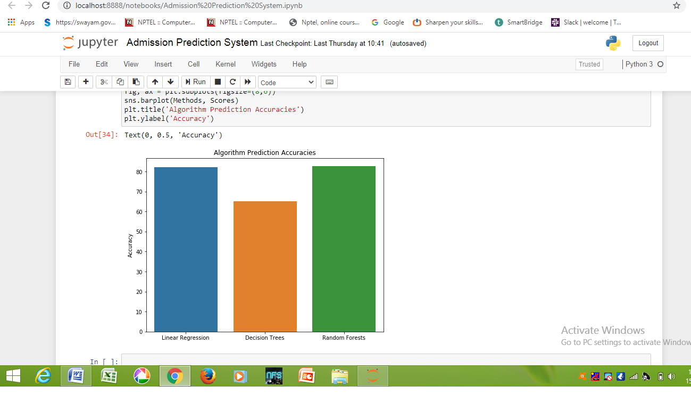

**OUTPUT:**

